Name: M.Arshini
REG NO:192424322

1. Write a Pandas program to select the distinct department id from
employees file.

Code:
import pandas as pd
data = {
'DEPARTMENT_ID': [10,20,30,40,50,60,70,80,90,100,110,120,130,140,150,160,170,180,190,200,210,220,230,240,250,260,270],
'DEPARTMENT_NAME': ['Administration','Marketing','Purchasing','Human Resources',
'Shipping','IT','Public Relations','Sales','Executive',
'Finance','Accounting','Treasury','Corporate Tax',
'Control And Credit','Shareholder Services','Benefits',
'Manufacturing','Construction','Contracting','Operations',
'IT Support','NOC','IT Helpdesk','Government Sales',
'Retail Sales','Recruiting','Payroll']
}
df = pd.DataFrame(data)
distinct_dept_ids = df['DEPARTMENT_ID'].drop_duplicates()
print("Distinct Department IDs:")
print(distinct_dept_ids.tolist())

Output:
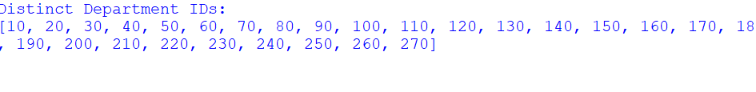

2. Write a Pandas program to display the IDs of employees who have
done two or more jobs in the past.

Code:
import pandas as pd
data = {
'EMPLOYEE_ID': [102,101,101,201,114,122,200,176,176,200],
'JOB_ID': ['IT_PROG','AC_ACCOUNT','AC_MGR','MK_REP',
'ST_CLERK','ST_CLERK','AD_ASST',
'SA_REP','SA_MAN','AC_ACCOUNT']
}

df = pd.DataFrame(data)
job_count = df.groupby('EMPLOYEE_ID')['JOB_ID'].count()
result = job_count[job_count >= 2]
print("Employees who have done two or more jobs:")
print(result.index.tolist())

Output:
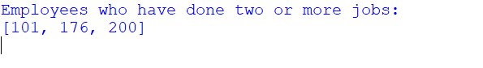

3. Write a Pandas program to display the details of jobs in descending
sequence on job title.

Code:
import pandas as pd
data = {
'JOB_ID':['AD_PRES','AD_VP','AD_ASST','FI_MGR','FI_ACCOUNT',
'AC_MGR','AC_ACCOUNT','SA_MAN','SA_REP','PU_MAN',
'PU_CLERK','ST_MAN','ST_CLERK','SH_CLERK',
'IT_PROG','MK_MAN','MK_REP','HR_REP','PR_REP'],

'JOB_TITLE':['President','Administration Vice President',
'Administration Assistant','Finance Manager',
'Accountant','Accounting Manager',
'Public Accountant','Sales Manager',
'Sales Representative','Purchasing Manager',
'Purchasing Clerk','Stock Manager',
'Stock Clerk','Shipping Clerk',
'Programmer','Marketing Manager',
'Marketing Representative',
'Human Resources Representative',
'Public Relations Representative']
}

df = pd.DataFrame(data)
result = df.sort_values(by='JOB_TITLE', ascending=False)

print(result)

Output:
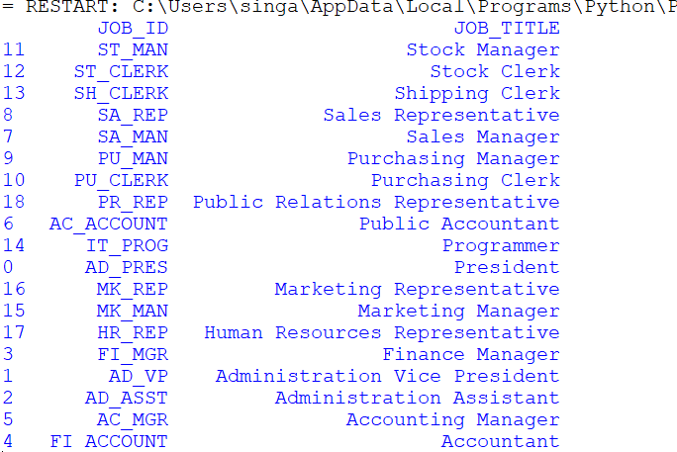

4. Write a Pandas program to create a line plot of the historical stock
prices of Alphabet Inc. between two specific dates.

Code:
import pandas as pd
import matplotlib.pyplot as plt

# Sample stock price data
data = {
'Date': ['2024-01-01', '2024-01-02', '2024-01-03',
'2024-01-04', '2024-01-05'],
'Close_Price': [140, 142, 141, 145, 148]
}

# Create DataFrame
df = pd.DataFrame(data)

# Convert Date column to datetime
df['Date'] = pd.to_datetime(df['Date'])

# Create Line Plot
plt.figure(figsize=(8,5))
plt.plot(df['Date'], df['Close_Price'], marker='o')

plt.title('Alphabet Inc. Stock Prices')
plt.xlabel('Date')
plt.ylabel('Closing Price ($)')
plt.grid(True)

plt.show()

Output:
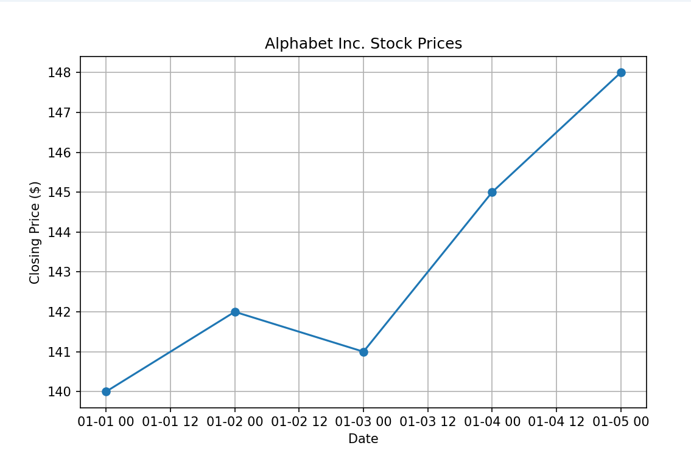

5. Write a Pandas program to create a bar plot of the trading volume of
Alphabet Inc. stock between two specific dates.
Code:
import pandas as pd
import matplotlib.pyplot as plt

# Sample trading volume data
data = {
'Date': ['2024-01-01', '2024-01-02', '2024-01-03',
'2024-01-04', '2024-01-05'],
'Volume': [1200000, 1500000, 1300000, 1700000, 1600000]
}

# Create DataFrame
df = pd.DataFrame(data)

# Create Bar Plot
plt.figure(figsize=(8,5))
plt.bar(df['Date'], df['Volume'])

plt.title('Alphabet Inc. Trading Volume')
plt.xlabel('Date')
plt.ylabel('Volume')

plt.show()
Output:
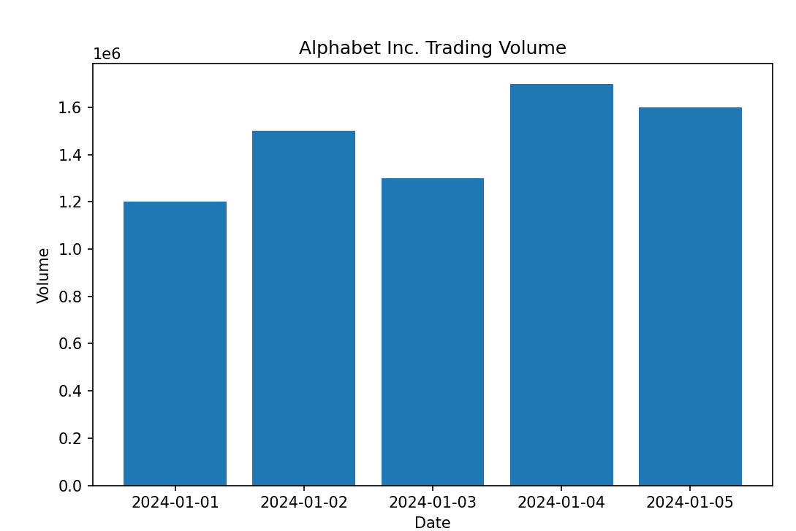

6. Write a Pandas program to create a scatter plot of the trading
volume/stock prices of Alphabet Inc. stock between two specific dates.
alphabet_stock_data:
Code:
import pandas as pd
import matplotlib.pyplot as plt

# Alphabet stock data
data = {
'Date': ['2023-01-02', '2023-01-10', '2023-01-18',
'2023-02-05', '2023-02-15', '2023-03-01',
'2023-03-10', '2023-03-20', '2023-04-05',
'2023-04-15'],

'Close': [91.80, 94.50, 96.20, 98.75, 101.30,
103.60, 105.40, 107.80, 110.20, 112.50],

'Volume': [25000000, 28000000, 26000000, 30000000,
31000000, 27000000, 29000000, 32000000,
33000000, 35000000]
}

# Create DataFrame
df = pd.DataFrame(data)

# Convert Date column to datetime
df['Date'] = pd.to_datetime(df['Date'])

# Select data between two dates
start_date = '2023-01-01'
end_date = '2023-03-31'

filtered_df = df[(df['Date'] >= start_date) &
(df['Date'] <= end_date)]

# Create Scatter Plot
plt.figure(figsize=(8,5))
plt.scatter(filtered_df['Volume'],
filtered_df['Close'])

plt.title('Alphabet Inc. Stock: Trading Volume vs Stock Price')
plt.xlabel('Trading Volume')
plt.ylabel('Closing Stock Price')
plt.grid(True)

plt.show()

Output:
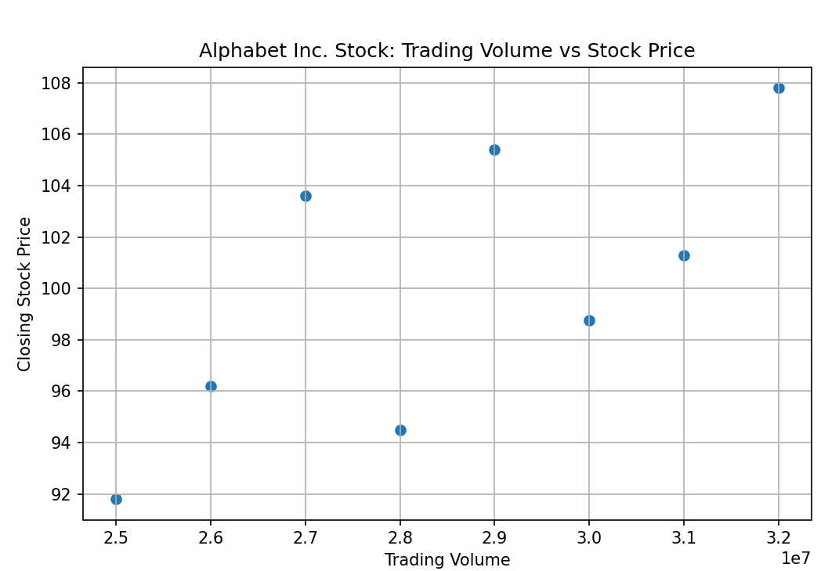

7. Write a Pandas program to create a Pivot table and find the maximum
and minimum sale value of the items.(refer sales_data table)
Code:
import pandas as pd
data = {
'Item': ['Television', 'Home Theater', 'Television', 'Cell Phone',
'Television', 'Home Theater', 'Television', 'Television',
'Television', 'Home Theater', 'Television', 'Home Theater',
'Home Theater', 'Television', 'Desk', 'Video Games',
'Home Theater', 'Cell Phone'],

'Sale_amt': [113810, 25000, 43128, 6075, 67088, 30000,
89850, 107820, 38336, 30000, 107820,
14500, 40500, 41930, 250, 936,
14000, 14400]
}

df = pd.DataFrame(data)

# Pivot Table
pivot_table = pd.pivot_table(
df,
values='Sale_amt',
index='Item',
aggfunc=['max', 'min']
)

print(pivot_table)

Output:
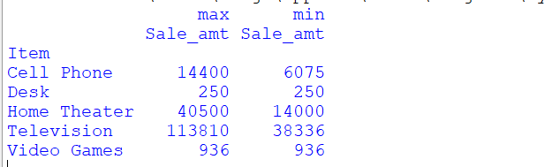

8. Write a Pandas program to create a Pivot table and find the item wise
unit sold. .(refer sales_data table)

Code:
import pandas as pd

# Sales Data
data = {
'Item': ['Television', 'Home Theater', 'Television', 'Cell Phone',
'Television', 'Home Theater', 'Television', 'Television',
'Television', 'Home Theater', 'Television', 'Home Theater',
'Home Theater', 'Television', 'Desk', 'Video Games',
'Home Theater', 'Cell Phone'],

'Units': [95, 50, 36, 27, 56, 60, 75, 90, 32,
60, 90, 29, 81, 35, 2, 16, 28, 64]
}

df = pd.DataFrame(data)

# Pivot Table
pivot_table = pd.pivot_table(
df,
values='Units',
index='Item',
aggfunc='sum'
)

print(pivot_table)
Output:
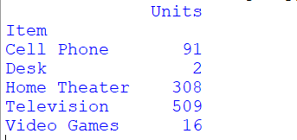

9. Write a Pandas program to create a Pivot table and find the total sale
amount region wise, manager wise, sales man wise. .(refer sales_data
table)

Code:
import pandas as pd
data = {
'Item': ['Television', 'Home Theater', 'Television', 'Cell Phone',
'Television', 'Home Theater', 'Television', 'Television',
'Television', 'Home Theater', 'Television', 'Home Theater',
'Home Theater', 'Television', 'Desk', 'Video Games',
'Home Theater', 'Cell Phone'],

'Sale_amt': [113810, 25000, 43128, 6075, 67088, 30000,
89850, 107820, 38336, 30000, 107820,
14500, 40500, 41930, 250, 936,
14000, 14400]
}

df = pd.DataFrame(data)

# Pivot Table
pivot_table = pd.pivot_table(
df,
values='Sale_amt',
index='Item',
aggfunc=['max', 'min']
)

print(pivot_table)

Output:
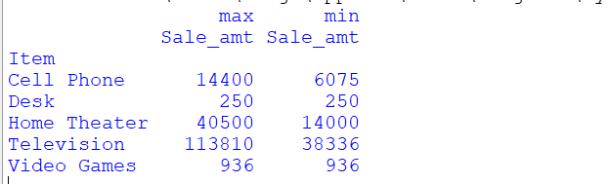

10.Create a dataframe of ten rows, four columns with random values. Write a
Pandas program to highlight the negative numbers red and positive numbers
black.

Code:
import pandas as pd
import numpy as np

# Create DataFrame with 10 rows and 4 columns
np.random.seed(10)

df = pd.DataFrame(
np.random.randint(-20, 21, size=(10, 4)),
columns=['A', 'B', 'C', 'D']
)

print("Original DataFrame:")
print(df)

# Function to highlight values
def highlight_color(val):
if val < 0:
return 'background-color:red; color:white'
else:
return 'background-color:black; color:white'

# Apply styling (Pandas 2.1+)
styled_df = df.style.map(highlight_color)

# Display styled DataFrame
print(styled_df)

Output:
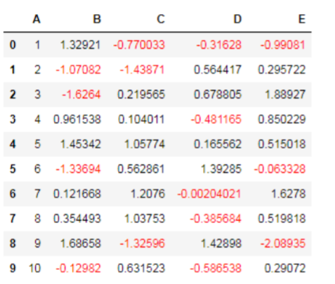

11.Create a dataframe of ten rows, four columns with random values. Convert
some values to nan values. Write a Pandas program which will highlight the
nan values.

Code:
import pandas as pd
import numpy as np

df = pd.DataFrame(np.random.randn(10, 4),
columns=['A', 'B', 'C', 'D'])

df.iloc[1, 2] = np.nan
df.iloc[4, 0] = np.nan
df.iloc[7, 3] = np.nan

styled_df = df.style.highlight_null(color='yellow')

print(df)
styled_df

Output:
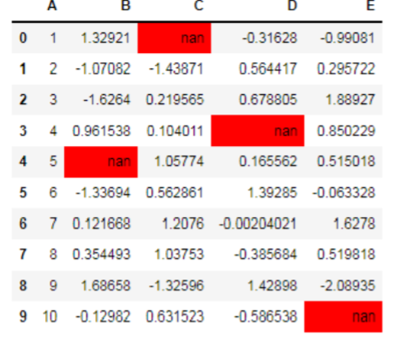

12.Create a dataframe of ten rows, four columns with random values. Write a
Pandas program to set dataframe background Color black and font color
yellow.

Code:
import pandas as pd
import numpy as np

df = pd.DataFrame(np.random.randn(10, 4),
columns=['A', 'B', 'C', 'D'])

df.iloc[1, 2] = np.nan
df.iloc[4, 0] = np.nan
df.iloc[7, 3] = np.nan

styled_df = df.style.highlight_null(color='yellow')

print(df)
styled_df

Output:
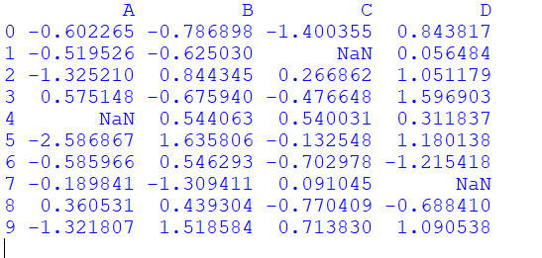

13.Write a Pandas program to detect missing values of a given DataFrame.
Display True or False.

Code:
import pandas as pd
import numpy as np

data = {
'A': [1, 2, np.nan, 4],
'B': [5, np.nan, 7, 8],
'C': [9, 10, 11, np.nan]
}

df = pd.DataFrame(data)

print("Original DataFrame:")
print(df)

print("\nMissing Values (True/False):")
print(df.isnull())

Output:
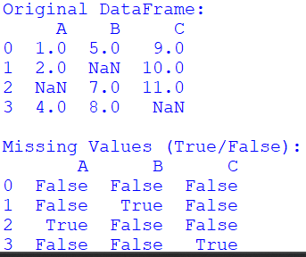
14. Write a Pandas program to find and replace the missing values in a given
DataFrame which do not have any valuable information.

Code:
import pandas as pd
import numpy as np

data = {
'A': [1, np.nan, 3, 4],
'B': [5, 6, np.nan, 8],
'C': [np.nan, 10, 11, 12]
}

df = pd.DataFrame(data)

print("Original DataFrame:")
print(df)

df.fillna(0, inplace=True)

print("\nDataFrame after replacing missing values:")
print(df)

Output:
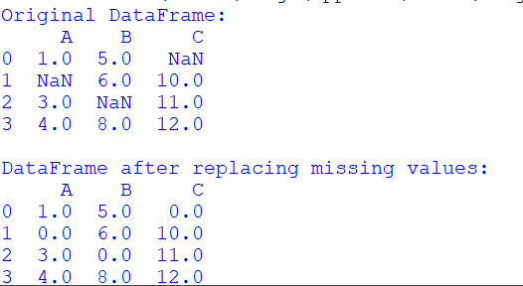
15.Write a Pandas program to keep the rows with at least 2 NaN values in a
given DataFrame.

Code:
import pandas as pd
import numpy as np

data = {
'A': [1, np.nan, np.nan, 4],
'B': [np.nan, np.nan, 3, 4],
'C': [np.nan, 2, np.nan, 4],
'D': [1, 2, 3, np.nan]
}

df = pd.DataFrame(data)

print("Original DataFrame:")
print(df)

result = df[df.isna().sum(axis=1) >= 2]

print("\nRows with at least 2 NaN values:")
print(result)

Output:
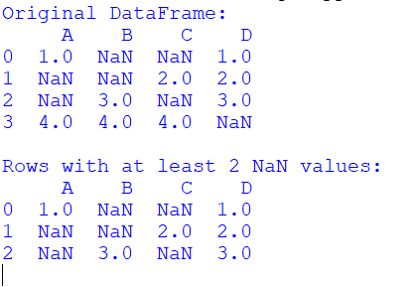
16.Write a Pandas program to split the following dataframe into groups based
on school code. Also check the type of GroupBy object.

Code:
import pandas as pd

data = {
'school_code': ['s001', 's002', 's001', 's003', 's002', 's001'],
'school_name': ['ABC', 'XYZ', 'ABC', 'PQR', 'XYZ', 'ABC'],
'students': [500, 600, 450, 700, 550, 480]
}

df = pd.DataFrame(data)

grouped = df.groupby('school_code')

print("Type of GroupBy Object:")
print(type(grouped))

print("\nGroups:")
for name, group in grouped:
print("\nSchool Code:", name)
print(group)

Output:
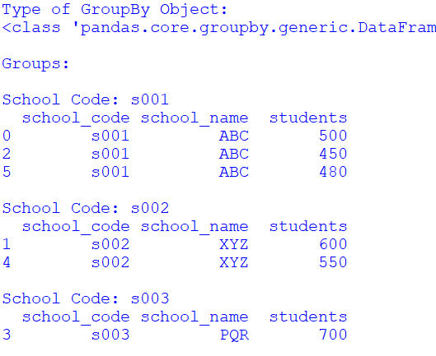
17.Write a Pandas program to split the following dataframe by school code
and get mean, min, and max value of age for each school.

Code:
import pandas as pd

data = {
'school_code': ['s001', 's002', 's001', 's003', 's002', 's001'],
'student_name': ['Raj', 'Priya', 'Arun', 'Kiran', 'Meena', 'Vijay'],
'age': [15, 16, 14, 17, 15, 16]
}

df = pd.DataFrame(data)

result = df.groupby('school_code')['age'].agg(['mean', 'min', 'max'])

print(result)

Output:

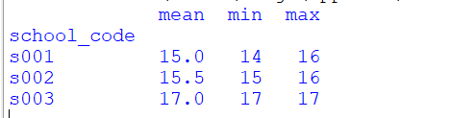

18.Write a Pandas program to split the following given dataframe into groups
based on school code and class.

Code:
import pandas as pd

data = {
'school_code': ['s001', 's001', 's002', 's002', 's003', 's003'],
'class': ['V', 'VI', 'V', 'VI', 'V', 'VI'],
'student_name': ['Raj', 'Priya', 'Arun', 'Meena', 'Kiran', 'Vijay'],
'age': [10, 11, 10, 12, 11, 12]
}

df = pd.DataFrame(data)

grouped = df.groupby(['school_code', 'class'])

for name, group in grouped:
print("\nGroup:", name)
print(group)

Output:
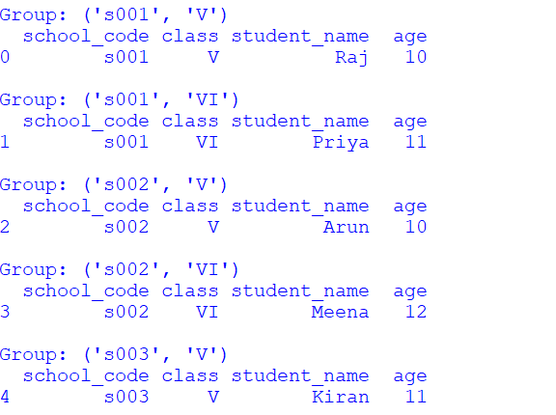

19.Write a Pandas program to display the dimensions or shape of the World
alcohol consumption dataset. Also extract the column names from the dataset.

Code:
import pandas as pd
data = {
'Year': [1987, 1989, 1985, 1986, 1987],
'WHO region': ['Africa', 'Americas', 'Africa', 'Europe', 'Asia'],
'Country': ['Algeria', 'Brazil', 'Nigeria', 'France', 'India'],
'Beverage Types': ['Wine', 'Beer', 'Spirits', 'Wine', 'Beer'],
'Display Value': [0.1, 2.5, 0.3, 8.7, 1.2]
}

df = pd.DataFrame(data)

print("Shape of Dataset:")
print(df.shape)

print("\nColumn Names:")
print(df.columns)

Output:
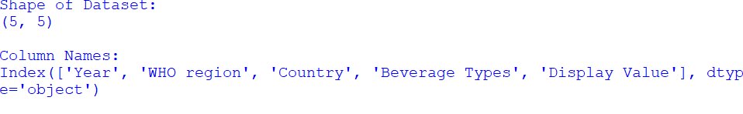

20.Write a Pandas program to find the index of a given substring of a
DataFrame column.

Code:
import pandas as pd

df = pd.DataFrame({
'Name': ['Raj Kumar', 'Priya Sharma', 'Arun Kumar', 'Meena Singh']
})

substring = 'Kumar'

df['Index_Position'] = df['Name'].str.find(substring)

print(df)

Output:
